FLORIDA FOLDING GATES
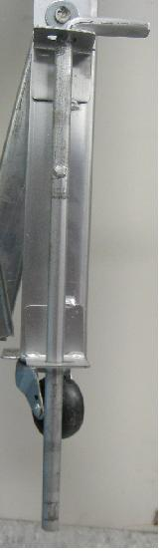
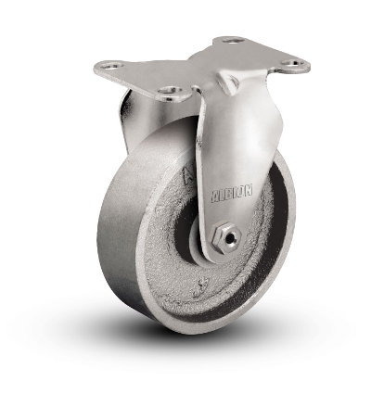
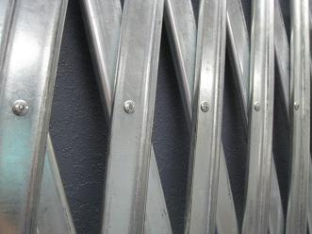

GALVANIZED STEEL
We take pride in our product. Our folding gates are made of galvanized steel, not painted bare iron.
The advantages are low maintenance, no flaking paint, no corrosion, no rust, and a high quality appearance.
1 ½” WIDE STEEL CHANNELS
Our steel channels that are 100% wider than the competition.
Florida Folding Gates, gates are manufactured with 1 ½ inch galvanized steel channels.
The competitions are ¾ inch non-galvanized.
We give our customer more steel per square foot of gate at a LOWER PRICE.

Florida Folding Gates are constructed with Aircraft Quality Zinc Plated Steel Rivets
Other manufacturers use aluminum pop rivets that will come apart and separate with heavy usage. We use steel rivets with Zinc plating to prevent corrosion and guarantee a longer life span.

STEEL WHEELS
Our steel wheels will with stand heavy impacts and heavy continuous use. Our steel wheels will never come apart unlike the common use of plastic wheels on other folding gates.
* Custom Sized Folding Gates Available Upon Request.

Buy Factory Direct
We Ship Nationwide
We Export
Miami Factory
9780 NW 79 Ave
HIALEAH GARDENS, FL 33016
TEL (305) 698-3550
FAX (305) 698-3552

Tampa Factory
8803 Enterprise Cove
Tampa, FL 33637
Tel: (813) 987-9065
Fax: (813) 984-6895



